20. DNS (Domain Name System) Server

Tasks

1. Install BIND9 DNS server on your Linux machine and verify the installation by checking the version with the
named -v command.

ANS:

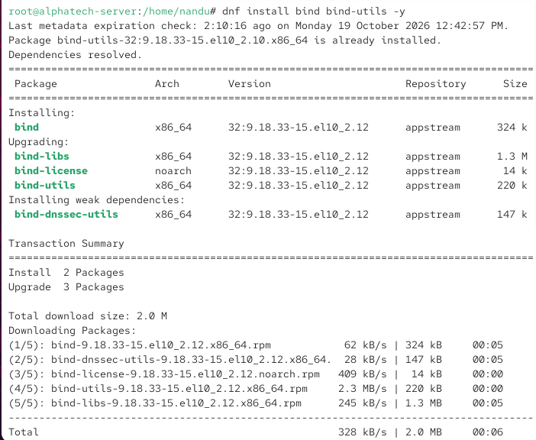

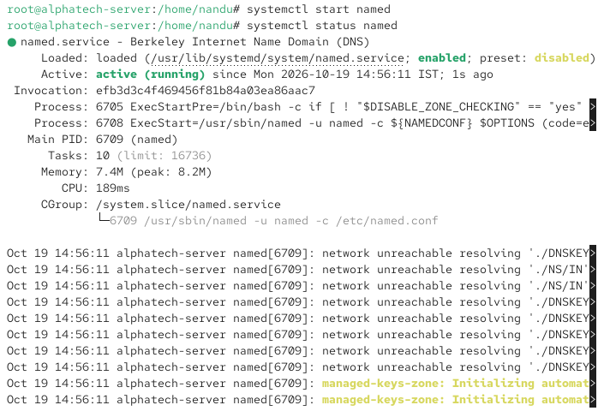

2. Configure a basic DNS zone file in /etc/bind/ for a custom domain like myzomatoclone.local, mapping it to 127.0.0.1, and restart the DNS service to apply changes. Edit named.conf.local and create a new zone file using db.local as a template.

ANS:

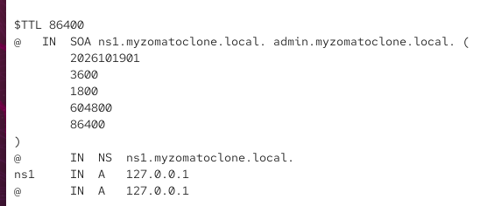

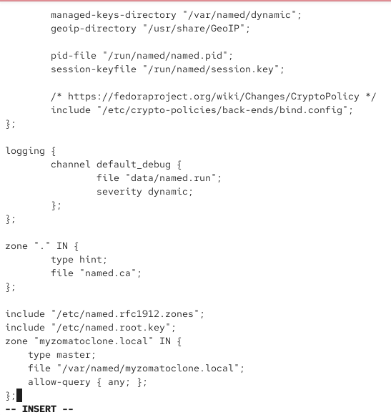

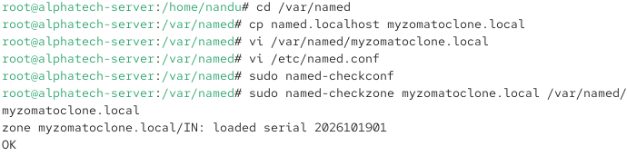

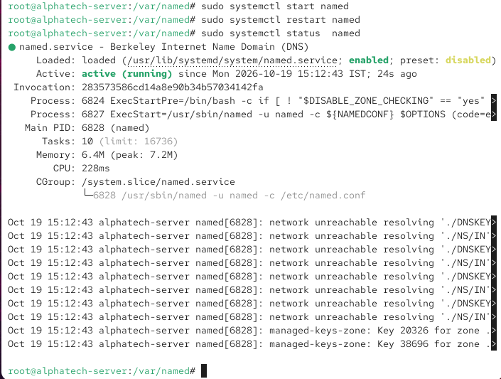

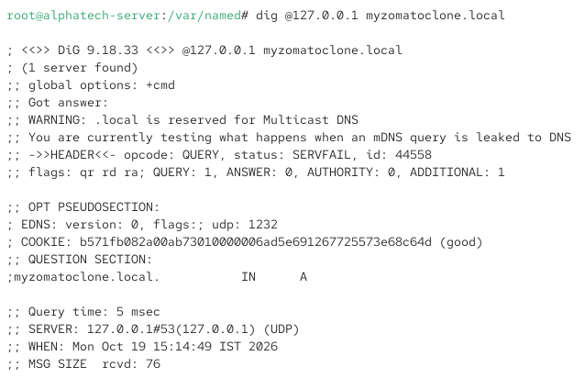

3. Set your system's DNS resolver to use your local BIND9 server and test domain resolution for myzomatoclone.local using the dig or nslookup command.

ANS:

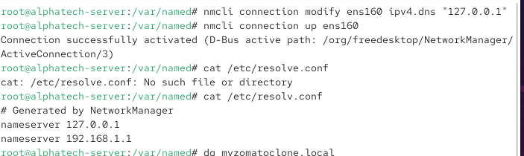

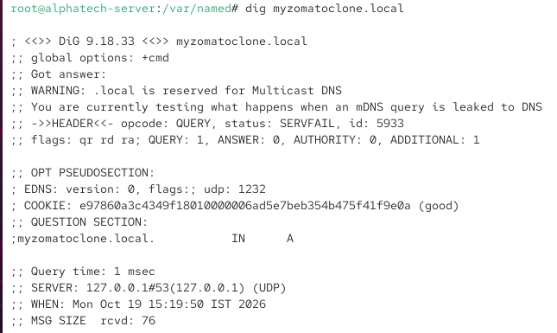

4. Add a CNAME record in your zone file to create an alias foodsearch.myzomatoclone.local that points to myzomatoclone.local, then verify the alias works with dig.

ANS:

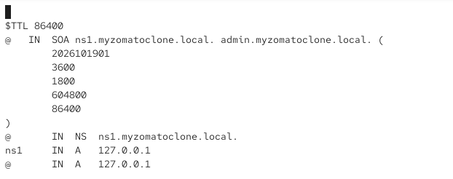

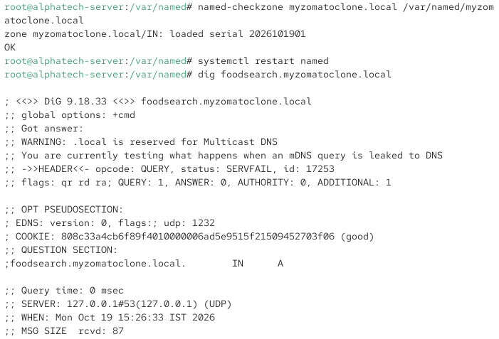

5.Find and fix the error in this zone file snippet: 'myzomatoclone.local. IN A 127.0.0.1 foodsearch IN CNAME myzomatoclone.local.' — the CNAME is not resolving as expected.Check the syntax and placement of the CNAME record.

ANS:

